CSCI 222 – Group x – Version Control

The group utilized GitHub as the version control management for the project

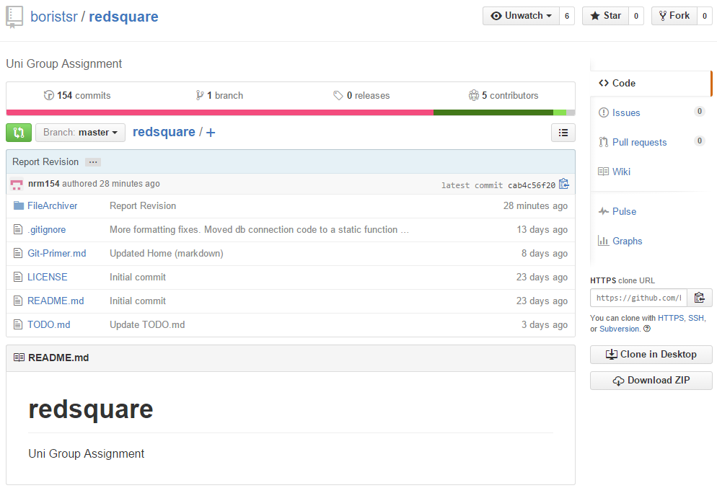

This is the top level of the Git repo

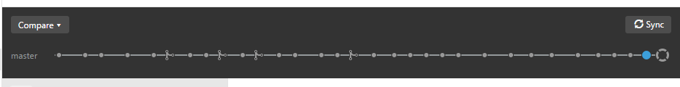

This shows the entire timeline of the commit history to the Git include when branches were merged, each circle allows you to go back and view previous versions of the repository

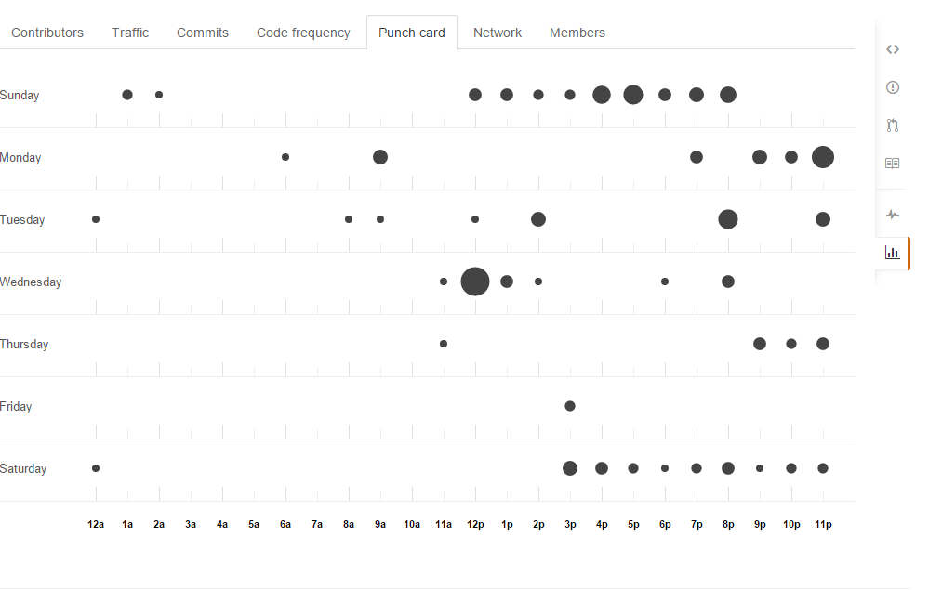

The above image shows the amount of commits by the group, which day the commits occurred and at what time, this shows a few bursts of commits, and a trend of the group to commit in the later parts of the day

<insert img of the final commit statistics showing each member commits here >